City of Melbourne Data Science MS Planner Tutorial – Adding a New Use Case

This tutorial explains how to add a new use case card to the MS Planner for the Data Science Team.

# City of Melbourne Planner

The City of Melbourne Planner is located within the City of Melbourne Channel and can be accessed via the tabs at the top.

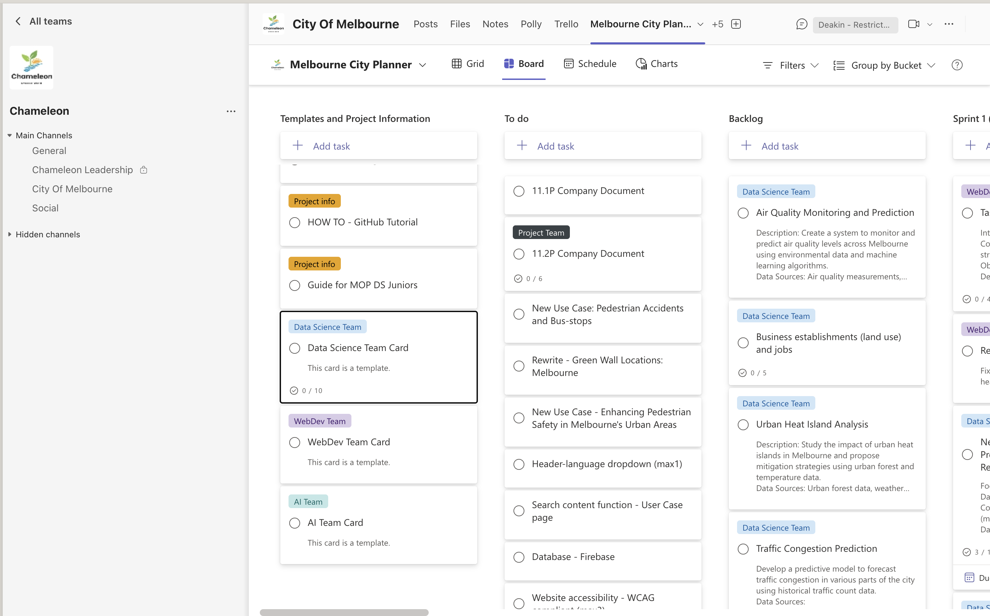

# Templates and Project Information

Once you are in the Melbourne City Planner, templates and project information are stored in the list on the left.

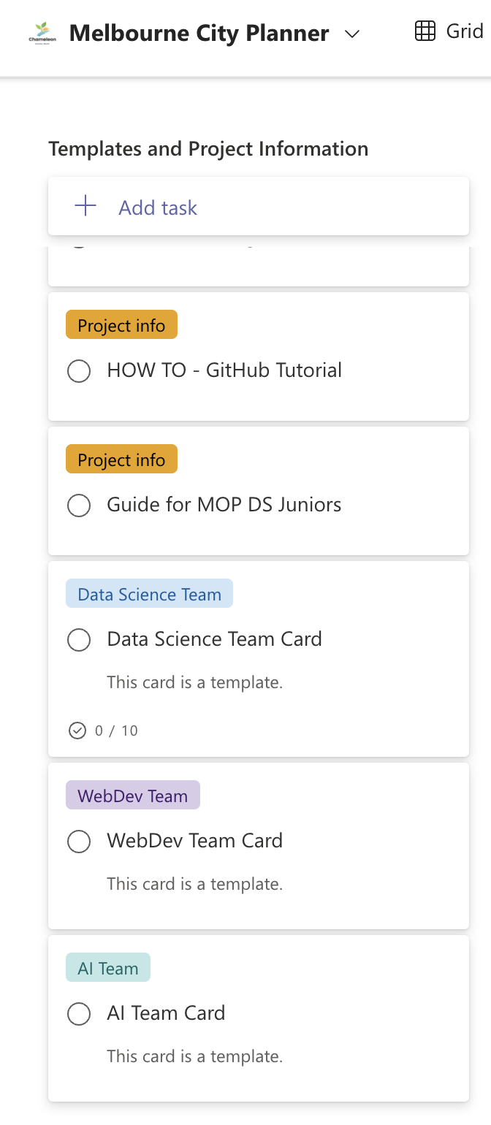

# Data Science Team Card Template

The "Data Science Team Card" is the template you should use to add your use case. Copy this task using the "More" button in the top right corner.

Fill out the task with a new name and allocate it to the correct bucket. Please ensure if this is a new use case the Task name starts with “New Use Case - ”. If this is your use case, you can place the task directly into Sprint 1.

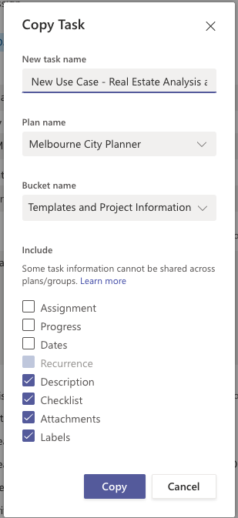

After clicking “Copy”, you will find this card in the designated bucket. From there, you can assign it to yourself and other team members working on the same use case. Additionally, please ensure you add a focus area and a brief description of your use case in the notes and links to the databases which you will be using.

Focus areas include:

* Environment and Wellbeing
* Transport and Safety
* Business and Activity

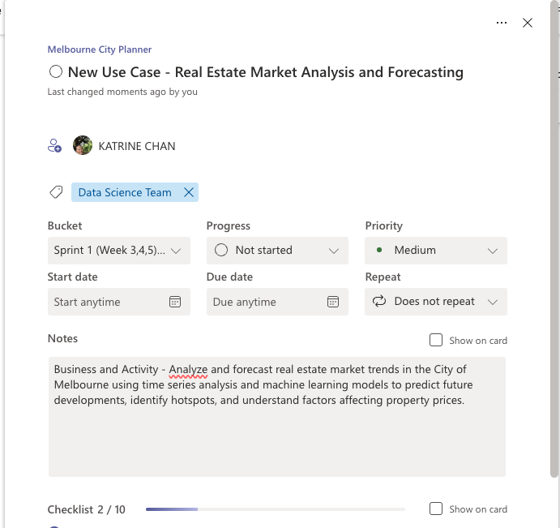

This template provides a basic checklist for your use case; however, feel free to add additional steps as needed.

# Alternative use of Data Science Team Card Template

In addition to using the "Data Science Team Card" template to create new use cases, this template can also be utilized for creating new cards for API repointing. To begin, copy the “Data Science Team Card” by clicking the "More" button in the top right corner and selecting “Copy Task”.

Fill out the task with a new name and allocate it to the correct bucket; this may be “Backlog” or the current sprint. As this card will be an API repointing card, please ensure the task name starts with “New API –”.A screenshot of a computer

After clicking "Copy," you will find the card in the designated bucket. From there, you can fill out the card with relevant information, add a brief description in the notes section, and include a checklist with tasks appropriate for this card.

# Author

Katrine Chan